**Name: Nikhil rane**

**Roll no: SE41**

**Assignment 5**

**REGEX ASSIGNMENT – PYTHON**

Q1. Starting with ‘a’ in given string. Str = ‘an apple a day keeps doctor away’

CODE:

import re  
  
str = 'an apple a day keeps doctor away'  
prog = re.compile(r'\ba\w+\b')  
result = prog.findall(str)  
print(result)

OUTPUT:

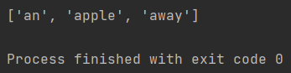

Q2. Starting with a numeric digit. Str =’The meeting will be conducted on 1 st and 21 st of every month’

CODE:

import re  
  
str = "The meeting will be conducted on 1st and 21st of every month"  
prog = re.compile(r'\d+')  
result = prog.findall(str)  
print(result)

OUTPUT:

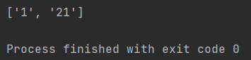

Q3. Having 5 character length. Str = ‘one two three four five six seven 8 9 10’

CODE:

import re  
  
str = 'one two three four five six seven 8 9 10'  
prog = re.compile(r'\b\w\w\w\w\w\b')  
result = prog.findall(str)  
print(result)

OUTPUT:

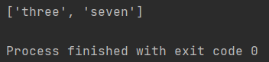

Q4. Having 5 characters length using search(). Str = ‘one two three four five six seven 8 9 10’

CODE:

import re  
  
str = 'one two three four five six seven 8 9 10'  
prog = re.compile(r'\b\w\w\w\w\w\b')  
result = prog.search(str)  
print(result.group())

OUTPUT:

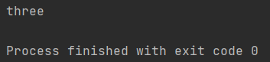

Q5. That are having the length of at least 4 character. Str = ‘one two three four five six seven 8 9 10’

CODE:

import re  
  
str = 'one two three four five six seven 8 9 10'  
prog = re.compile(r'\b\w\w\w\w+\b')  
result = prog.findall(str)  
print(result)

OUTPUT:

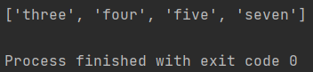

Q6. With 3 or 4 or 5 characters length. Str = ‘one two three four five six seven 8 9 10’

CODE:

import re  
  
str = 'one two three four five six seven 8 9 10'  
prog = re.compile(r'\b\w\w\w\b|\b\w\w\w\w\b|\b\w\w\w\w\w\b')  
result = prog.findall(str)  
print(result)

OUTPUT:

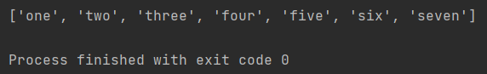

Q7. To retrieve only single digits from a string. Str = ‘one two three four five six seven 8 9 10’

CODE:

import re  
  
str='one two three four five six seven 8 9 10'  
prog=re.compile(r'\d\D')  
result=prog.findall(str)  
print(result)

OUTPUT:

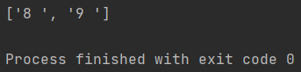

Q8. To retrieve last word of a string, if it starts with ‘t’. Str = ‘one two three one two three’

CODE:

import re  
  
str = 'one two three one two three'  
prog = re.compile(r'\bt\w*$')  
result = prog.search(str)  
print(result.group())

OUTPUT:

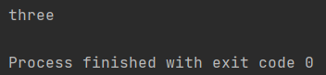

Q9. To retrieve the phone number of a person. Str = ‘Nageswara Rao: 987654321’

CODE:

import re  
  
str = 'Nageswara Rao: 987654321'  
prog = re.compile(r'\d+')  
result = prog.findall(str)  
print(result)

OUTPUT:

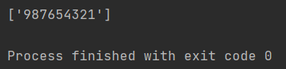

Q10. To retrieve only name and not a number from a string. Str =’ Nageswara Rao: 987654321’

CODE:

import re  
  
str ='Nageswara Rao: 987654321'  
prog = re.compile(r'\w*\S\D')  
result = prog.findall(str)  
print(result)

OUTPUT:

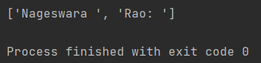

Q11. To find all words starting with ‘an’ or ‘ak’. Str =’anil akhil anant arun arati Arundhati Abhijit ankur’

CODE:

import re  
  
str = 'anil akhil anant arun arati Arundhati Abhijit ankur'  
prog = re.compile(r'\ban\w*|\bak\w*')  
result = prog.findall(str)  
print(result)

OUTPUT:

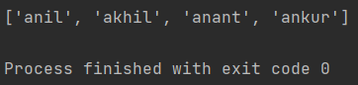

Q12. To retrieve date of birth from a string. Str =’Vijay 20 1-5-2001, Rohit 21 22-10-1990, Sita 22 15-09-2000’

CODE:

import re  
  
str = 'Vijay 20 1-5-2001, Rohit 21 22-10-1990, Sita 22 15-09-2000'  
prog = re.compile(r'\d*-\d*-\d*')  
result = prog.findall(str)  
print(result)

OUTPUT:

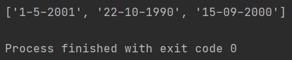

Q13. To search whether a given string is starting with ‘He’ or not. Str=’Hello World’

CODE:

import re  
  
str = 'Hello World'  
prog = re.compile(r'^He\w*')  
result = prog.findall(str)  
  
if result != []:  
 print('yes')  
else:  
 print('no')

OUTPUT:

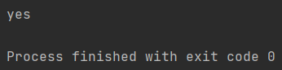

Q14. To search for a word at the ending of a string. Str=’Hello World’

CODE:

import re  
  
str = 'Hello World'  
prog = re.compile(r'\b\w+$')  
result = prog.findall(str)  
print(result)

OUTPUT:

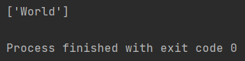

Q15. To search for a word at the ending of a string by ignoring the case. Str=’Hello World’

CODE:

import re  
  
str = 'Hello World'  
prog = re.compile(r'\b\w+$')  
result = prog.findall(str)  
  
print(result)

OUTPUT:



Q16. To retrieve marks and names from a given string. Str =’Rahul got 75 marks, Vijay got 55 marks, where as Subbu got 98 marks.’

CODE:

import re  
  
str = 'Rahul got 75 marks, Vijay got 55 marks, where as Subbu got 98 marks.'  
prog = re.compile(r'\b[A**-**Z]\w*|\b\d+')  
result = prog.findall(str)  
print(result)

OUTPUT:

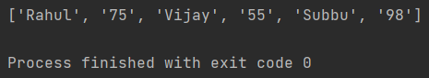

Q17. To retrieve the timings either ‘am’ or ‘pm’. Str =’The meeting timing will be at 8am or 9am or 4pm or 5pm’

CODE:

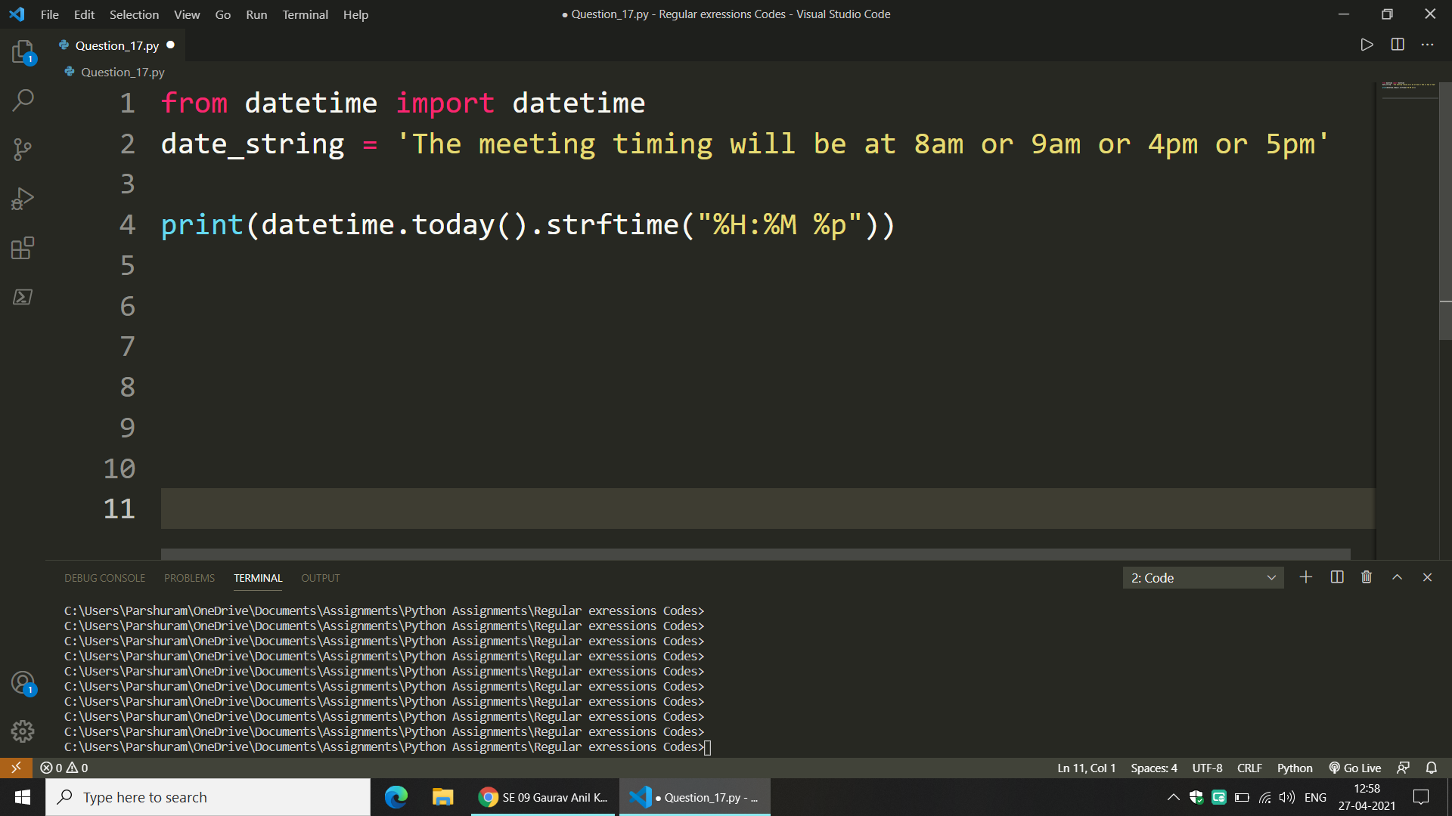

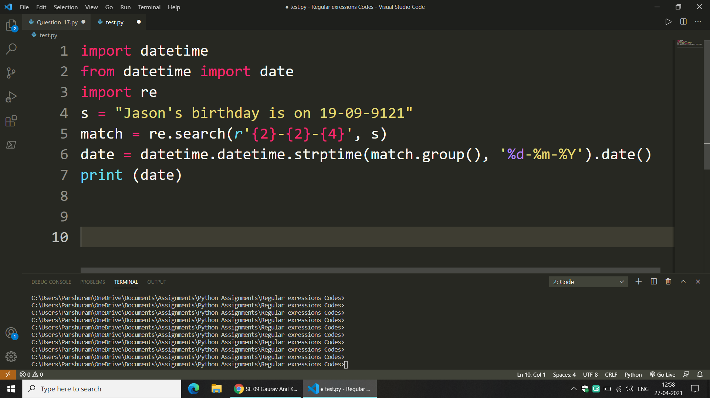

OUTPUT :

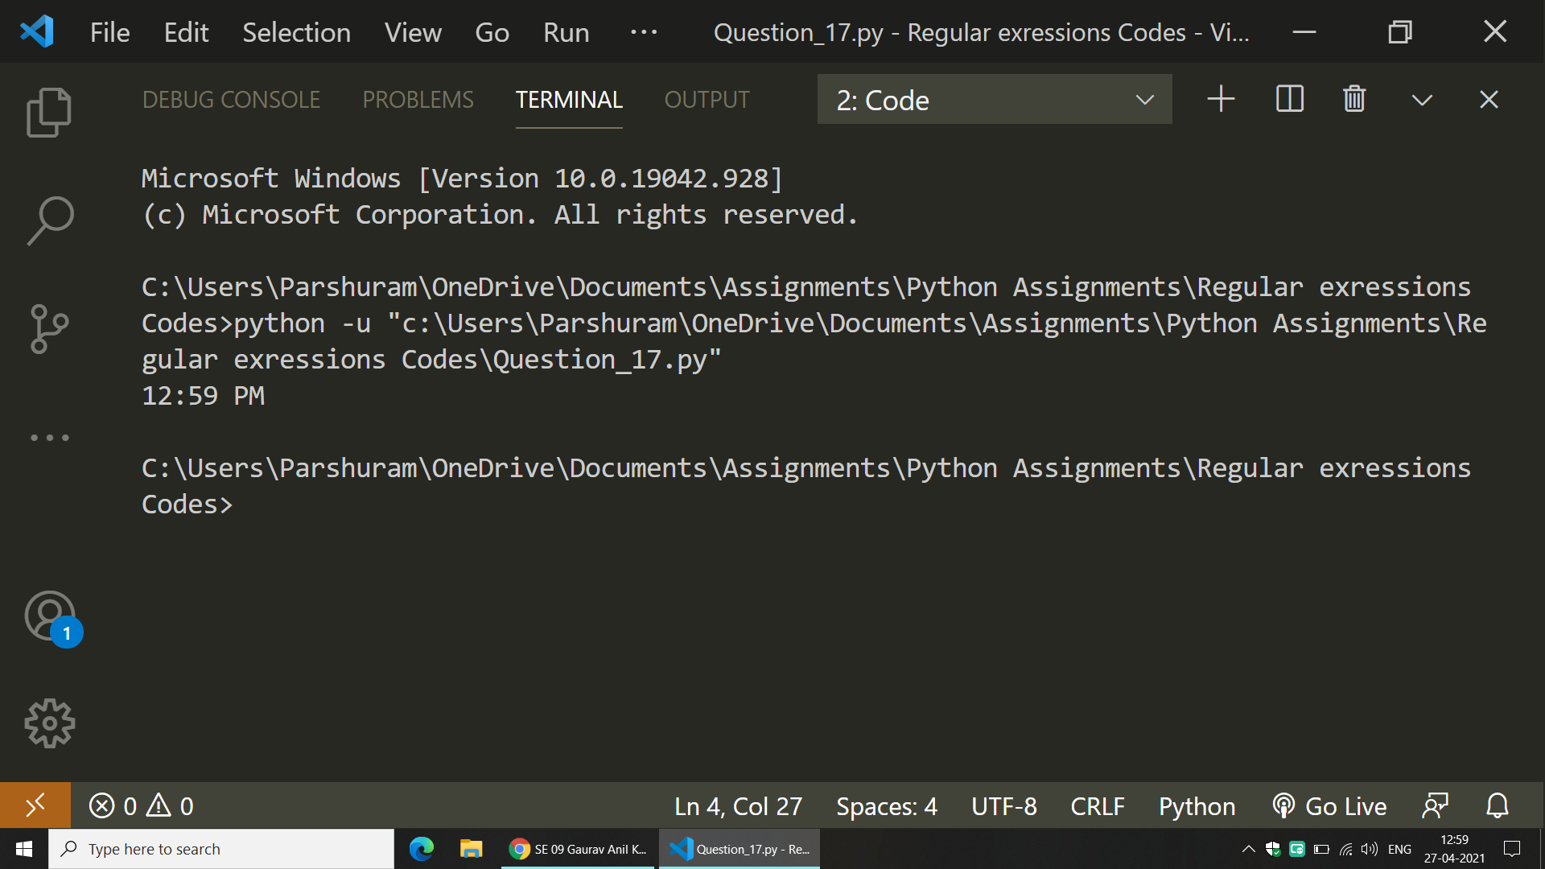

Q18. To retrieve data from a file using regular expression and then write that data into a file.

1001 Vijay Lucknow 15000

1002 Ajay Mumbai 10000

1003 Rahul Bangalore 20000

1004 Anay Kolkata 10000

Text File (t1.txt) :

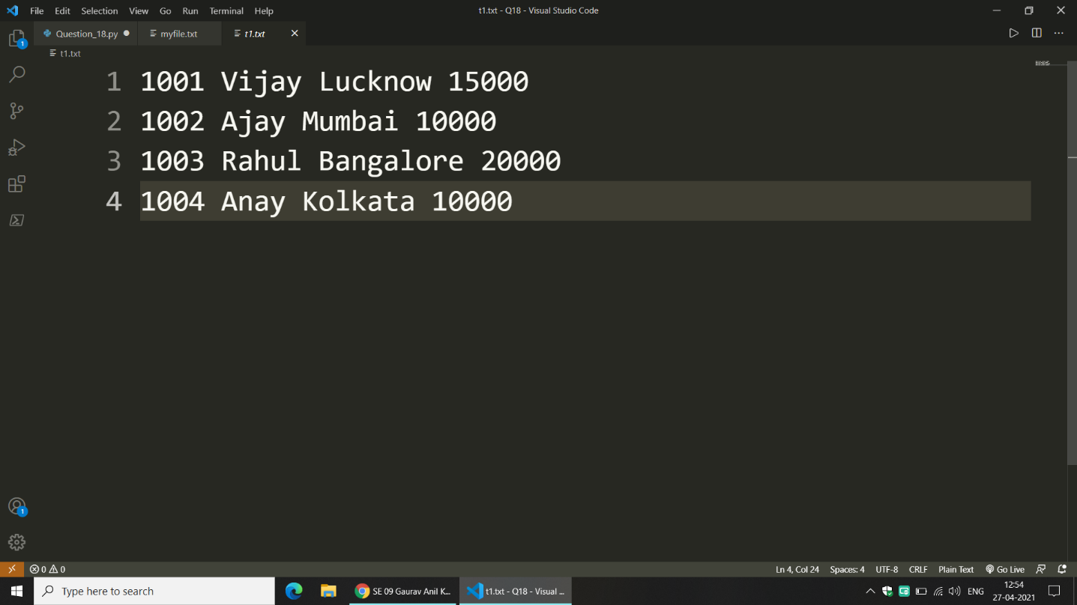

CODE:

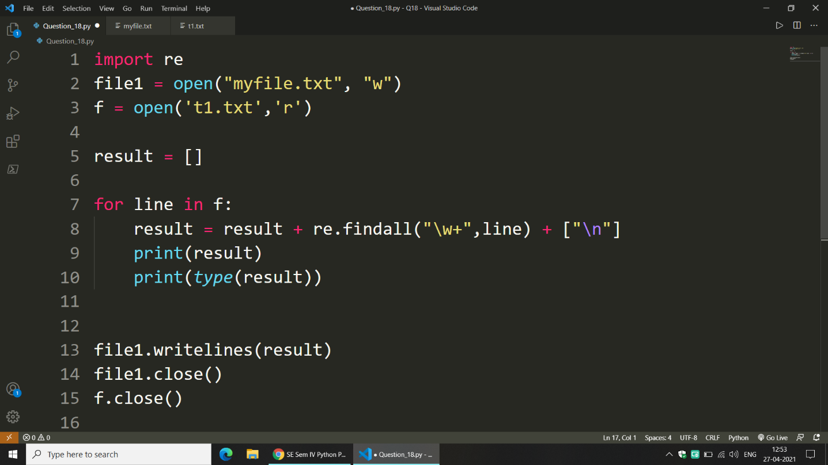

OUTPUT:

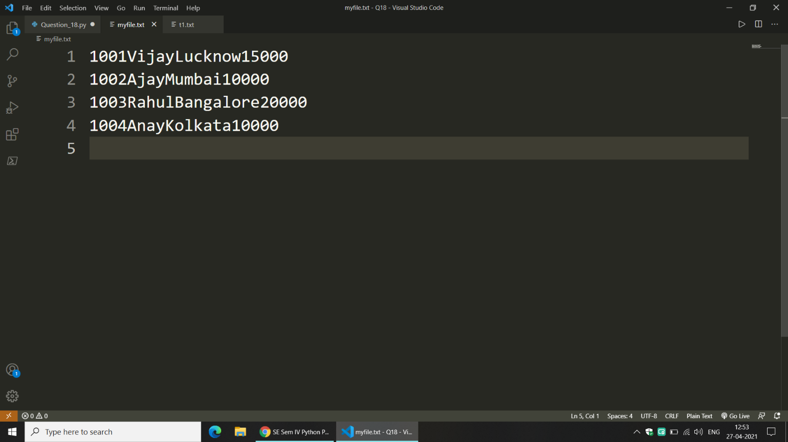

Q19. To retrieve data from HTML file.

CODE:

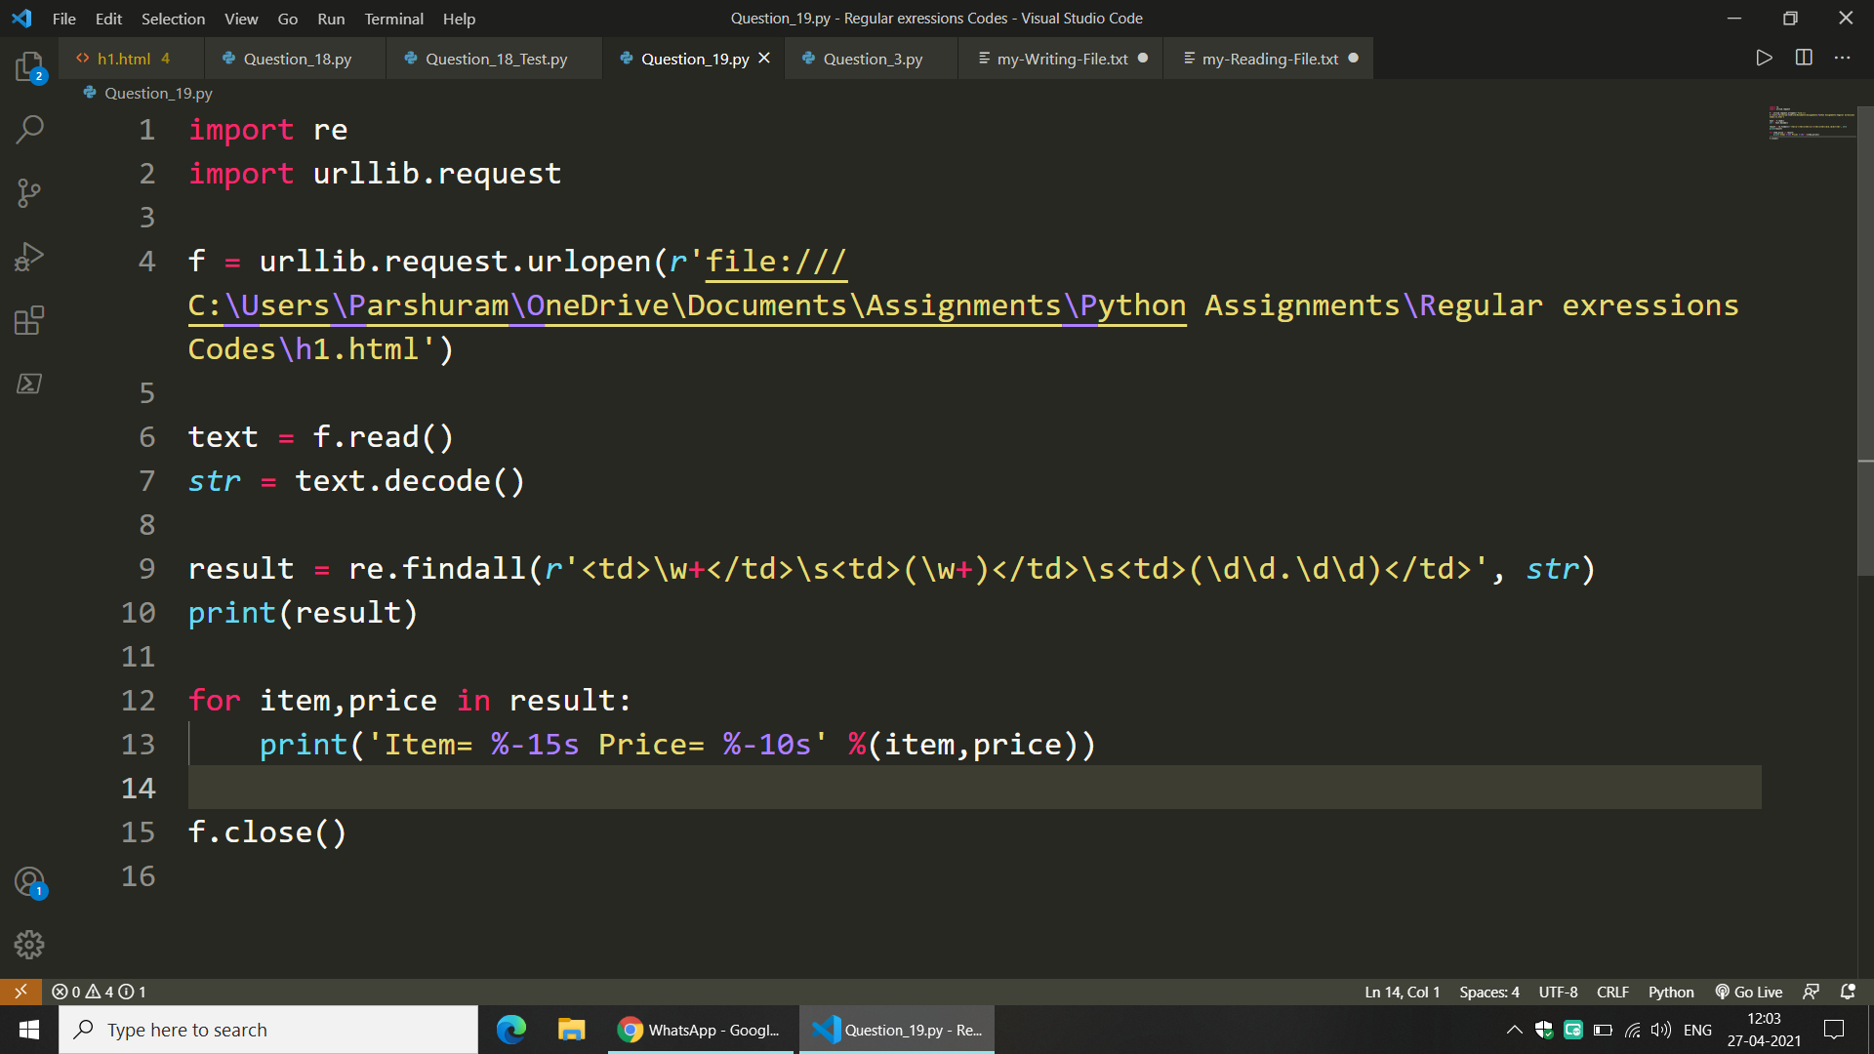

OUTPUT:

